# **Format for uploading details in GitHub and Slack in word file format**

**Student Name: Shrinivasa**

**Class and Sec: VI B**

**USN: 4AL17CS092**

|  |  |  |  |  |
| --- | --- | --- | --- | --- |
| **Online Test Details** | | | | |
| **Subject** |  | | | |
| **Semester** | **VI - B** | | **Duration** | **Minutes** |
| **%** | | **/** | | |

**Encl: snapshot of the test result**

|  |  |  |  |
| --- | --- | --- | --- |
| **Certification Course Details** | | | |
| **Course** | **Introduction to Cloud** | | |
| **Certificate Provider** | **Cognitiveclass.ai** | **Duration** | **6 hours** |

**Encl: snapshots of the daily class activities (at least two snap shots)**

**Progress on 14-06-2020**

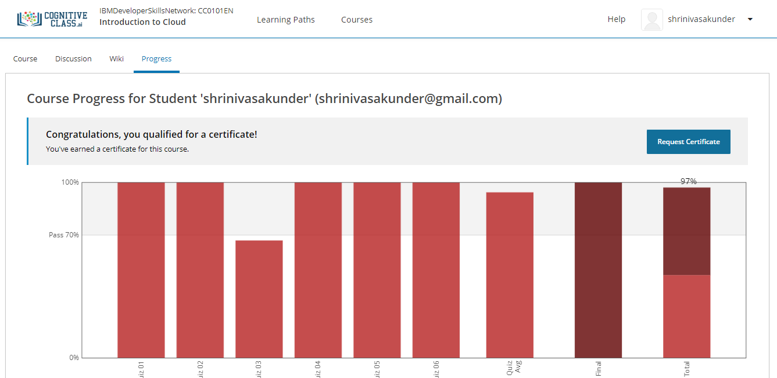

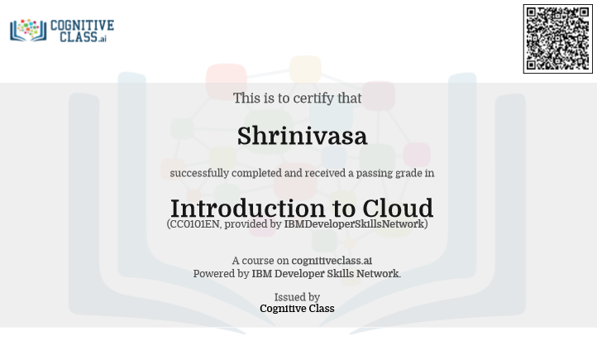



|  |  |
| --- | --- |
| **Coding Challenges** | |
| **Problem Statement: Pro1(java), Pro2(c), Pro3(python), Pro4(python).** | |
| **Status: Completed** | |
| **Uploaded the report both in GitHub & Slack** | **Yes** |

**Encl: snapshots of your response to challenge.**

[**https://github.com/Shrinivasakunder/certification-and-online-coding/tree/master/Online%20coding**](https://github.com/Shrinivasakunder/certification-and-online-coding/tree/master/Online%20coding)

**1. write a java program to remove specific characters in the String.**

import java.util.*;

public class Pro1 {

public static void main(String[] args) {

Scanner s = new Scanner(System.in);

System.out.println("Enter The String: ");

String str = s.nextLine().toLowerCase();

System.out.println("Enter The String To Remove Characters: ");

String rem = s.nextLine();

char[] a = new char[100];

int k=0;

for(int i=0;i<str.length();i++)

{

int c = 0;

for(int j=0;j<rem.length();j++)

{

if(str.charAt(i) == rem.charAt(j))

{

c = 1;

break;

}

}

if(c == 0)

{

a[k++]=str.charAt(i);

}

}

String fin = String.copyValueOf(a);

System.out.println("The Final String Is:\n"+fin);

}

}

**Output:**

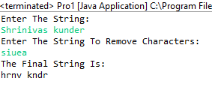

**2. Write a C Program to implement the Binary Reversal.**

#include <stdio.h>

int main()

{

int n;

printf("Enter The Number:\n");

scanf("%d",&n);

int i=0,b[500];

while(n>0)

{

b[i] = n%2;

n=n/2;

i++;

}

int j=i;

if(i%4 != 0)

{

for(j=i;j<i+(4-i%4);j++)

{

b[j]=0;

}

}

int k,s=0,p=j;

for(k=0;k<j;k++)

{

p--;

s=s+b[k]*pow(2,p);

}

printf("%d",s);

return 0;

}

**Output:**

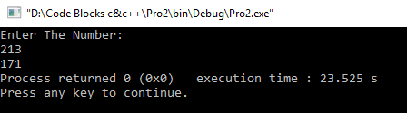

**3.** **Python Program to Take in a String and Replace Every Blank Space with Hyphen.**

s = input("Enter The String: ")

print(s.replace(" ", "-"))

**Output:**

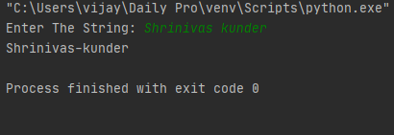

**4.** **Python Program to Calculate the Length of a String Without Using a Library Function.**

c = 0

for i in input("Enter The String: "):

c += 1

print(f'The Length Of String Is: {c}')

**Output:**

